Neutral Safety Switch R&R

on the 1972 280SE 4.5

by Tomguy

This is a step-by-step guide on how to remove, clean, Repair, and Replace your neutral safety switch. I don't know which models use this switch, but I would assume that most 108 and 109 chassis do, and probably others.
NOTE:
This article also tells you how to ADJUST your switch properly!
First, remove the neutral safety switch (found on the driver's side of the transmission) as well as the adjustment piece which moves the NSS.
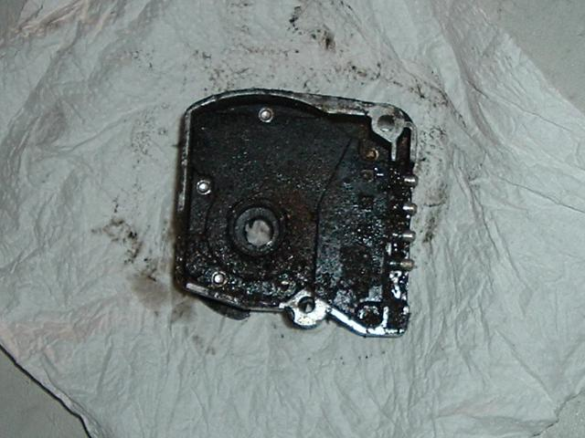
Most likely, your switch is pretty crudded and dirty after over 30 years of service. Wipe as much of the dirt and grease off of it before proceeding, so that you do not get dirt inside of it.
From the back side of the switch, using a 1/4" drill bit (you can use a larger one, just be careful to not drill through the plastic), drill the heads off of the aluminum rivets. If they spin freely, hold them on the other side so they do not move. There are 6 rivets in all.
Then, from the front side, with all the rivets out, push on the black circle that protrudes from the aluminum, as well as pulling gently on the pins on the opposite side. The plastic backing should slide out of the aluminum housing.
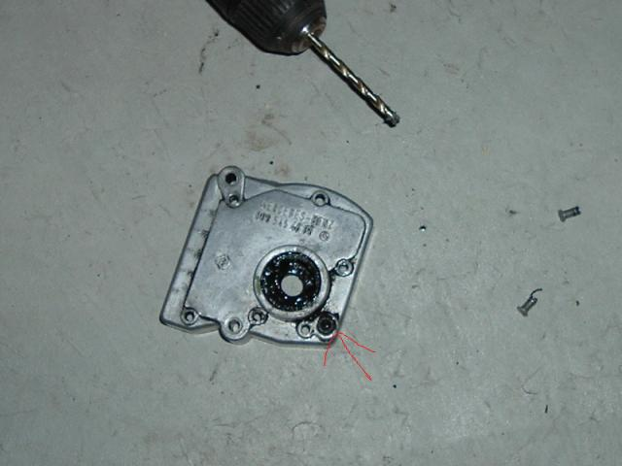
Clean all of the pieces with alcohol. Make SURE to remove any dirt and grease from the inside of the housing and the plastic back. The gasket and O-Rings, as well as the non-exposed parts of the "lobe" piece, must be free of dirt. If you want, you may actually wash the lobe and the housing. Be careful not to tear the rubber seal gasket. Clean the contacts out with contact cleaner, and make sure there is no dirt where the plug attatches to the pins.
Once cleaned, apply a light coating of clean, fresh grease to the O-rings, rubber gasket, and contact points on the lobe. Do not use too much grease! Put a small amount inside the backing and housing, where the O-Rings ride in, to help facilitate movement.
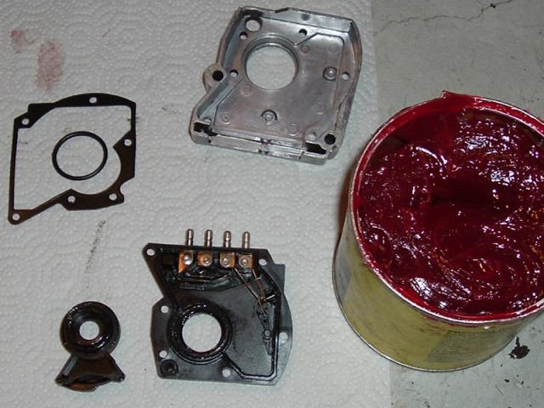
Reassemble the back O-Ring, Lobe, and plastic back. Carefully move the lobe and make sure that in Park and Neutral positions, that the contacts are closed (test with a multimeter, for 0 ohms of resistance). If they do not close, bend them slightly with needle-nose pliers. Do the same with the reverse switch. There should be no melted plastic prohibiting the contacts from moving - trim any with a hobby knife, if needed. I did have to do this on my switch for the reverse contacts.
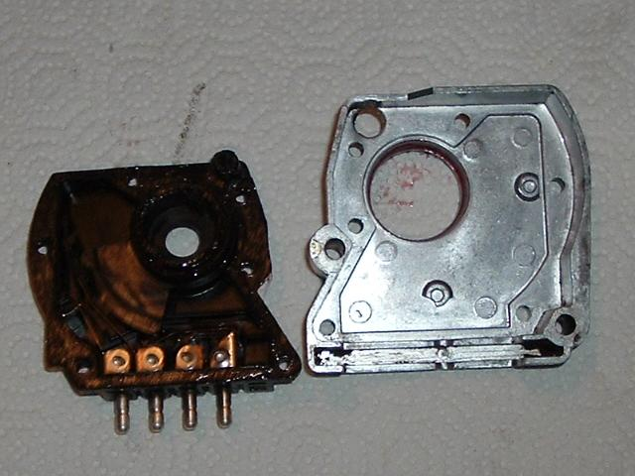
Finally, place the front O-Ring on the lobe and the gasket on the plastic back. Carefully put the aluminum housing over it. Using (6) 1/4" x 1/2" flat-head machine screws, or similar, reattach them through the original rivet holes. Tighten them carefuly in a standard cross-torque pattern.
ADJUSTMENT
Reinstall the switch. Leave the adjustment screw slightly loose. With the transmission in reverse, and the ignition on (so the backup lights actually light), move the adjustment tab until the backup lights go on - a helper may come in handy if you don't have a garage door to see the light reflect off of. MAKE SURE to set the parking brake AND chock the wheels! Testing reverse instead of testing park ensures that you get all three (Park, Reverse, and Neutral) right the first time. To double check, tighten the adjustment screw, then get inside the car. Turn the ignition off and move it through all the gears. Then, put it back into reverse and turn the ignition on. The backup lights should light. If not, readjust the tab until they do. Retest. Then, once that is successful, make sure the engine cranks in Park AND Neutral.
I hope this guide helps save some people ~$100 (or more, with labor) by doing this - it took me about an hour to do (at most), while taking pictures. Always remember standard safety procedures - chock the wheels and use the parking brake. Disconnect the coil wire to prevent accidental starting. If using a jack or jack stands, make sure your surface is hard and level, and your vehicle's weight is evenly distributed so it does not shift. Lastly, if you have a transistorized ignition, disconnect a lead going to the coil as, if the points are closed, the box will send voltage to the coil the entire time the ignition is in the "Run" position with the engine off, which can lead to overheating and failure of the ignition box.
- Tomguy

